Phone screen

**HTML:**

**CSS :**

**Open and close the nav menu:**

change the right and add transition.

To add comment in HTML /CSS:

1. Highlight the content and press
2. 

How to add Icon in front text?

1. Go to (font awesome 4 cdn) <https://www.bootstrapcdn.com/fontawesome/>

Copy the link below

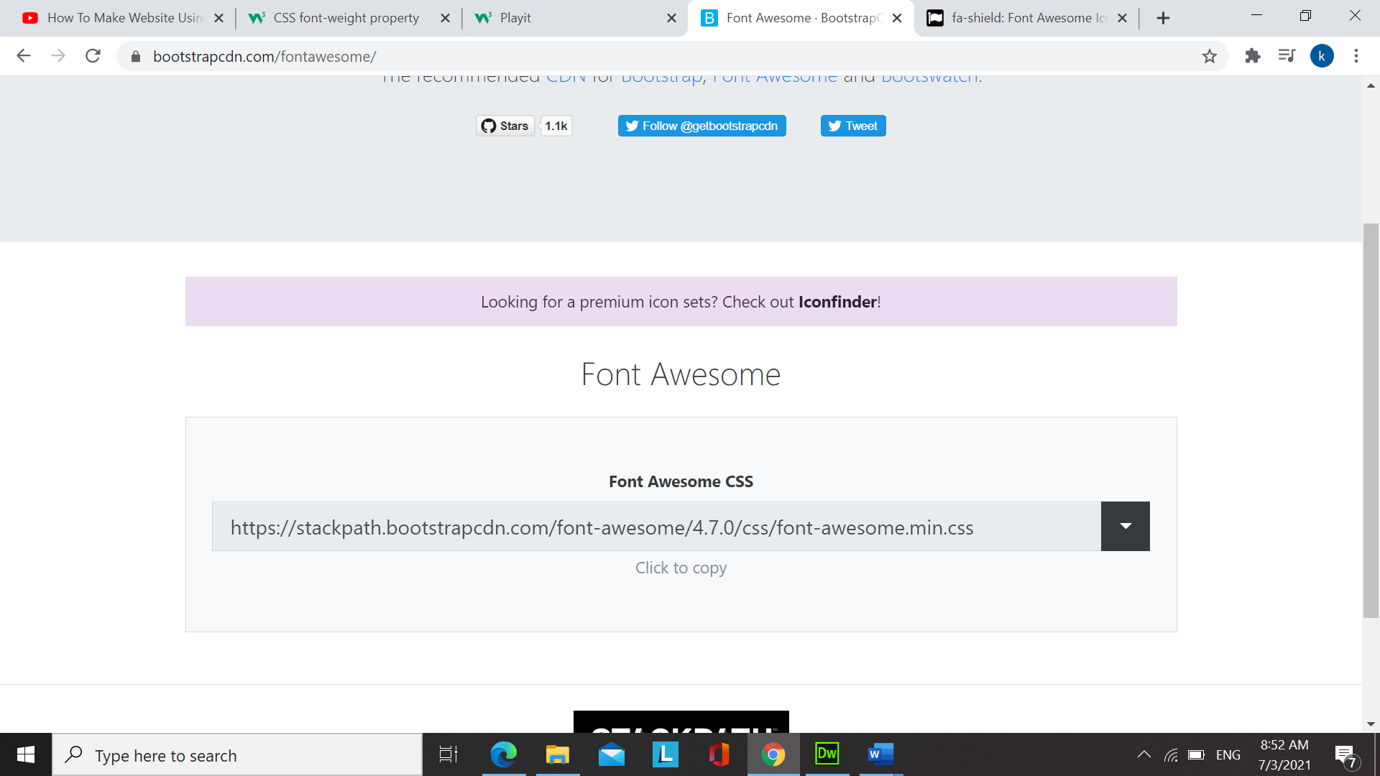

1. Then, go to (font awesome 4 cdn icons)

<https://fontawesome.com/v4.7.0/icons/>

search for the icon you want

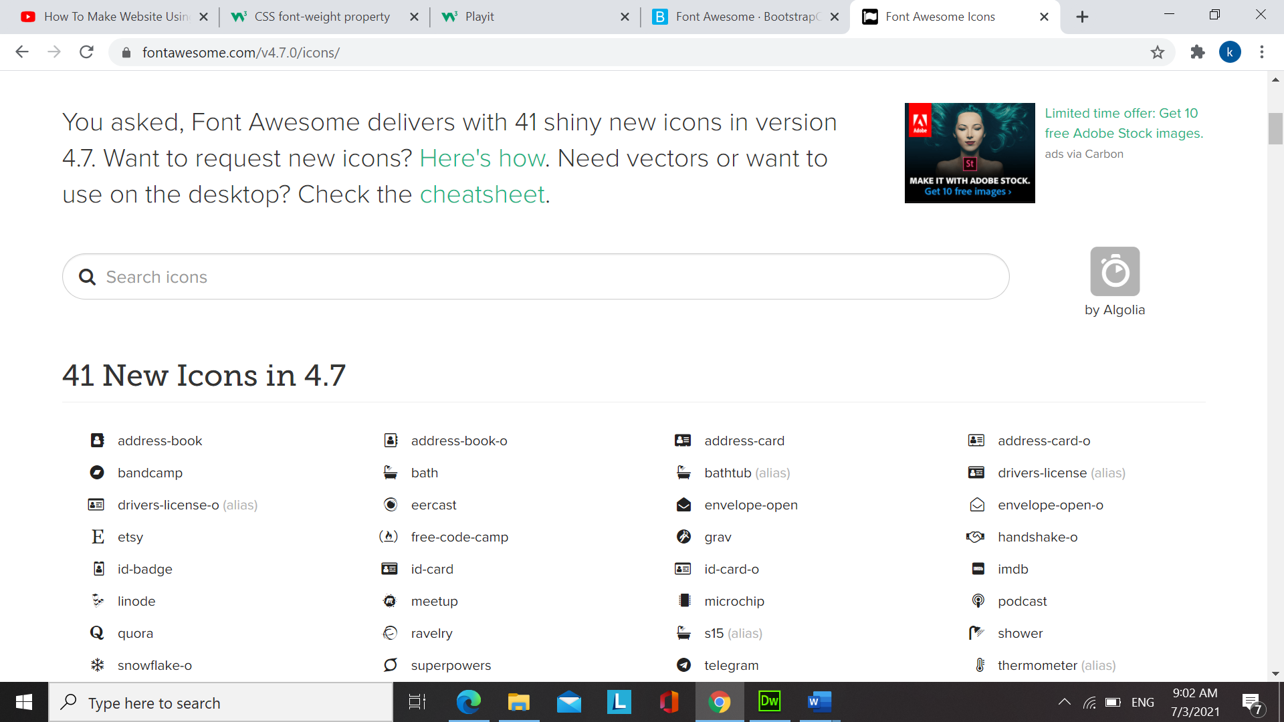

Then copy the link below to

1. 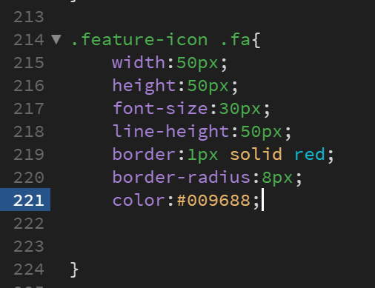Lastly write this code

Flex-wrap: wrap; (use for phone size)

Div Vs Span

span: inline(for inline button)

div: block

------------



You can go to the website by clicking “Go To PixemWeb”.



You can go to the website by clicking the picture.

The <nav> tag defines **a set of navigation links**.

box-sizing: content-box;

when you set the width to 50px the padding and border will be **added** to the 50px width.

box-sizing: border-box;

when you set the width to 50px the padding and border will be **included** in the 50px width.

display: inline;

* **Cannot** set the height and width
* Take the space as much as they needed

-------------------

display: block;

* **can** set the height and width
* Take the full width of the page 100%, so each box start at a new line

--------------------

display: inline-block;

* Can set the height and width
* Can place the items side by side at the same time

Video provides a powerful way to help you prove your point. When you click Online Video, you can paste in the embed code for the video you want to add. You can also type a keyword to search online for the video that best fits your document.

To make your document look professionally produced, Word provides header, footer, cover page, and text box designs that complement each other. For example, you can add a matching cover page, header, and sidebar. Click Insert and then choose the elements you want from the different galleries.

Themes and styles also help keep your document coordinated. When you click Design and choose a new Theme, the pictures, charts, and SmartArt graphics change to match your new theme. When you apply styles, your headings change to match the new theme.

Save time in Word with new buttons that show up where you need them. To change the way a picture fits in your document, click it and a button for layout options appears next to it. When you work on a table, click where you want to add a row or a column, and then click the plus sign.

Reading is easier, too, in the new Reading view. You can collapse parts of the document and focus on the text you want. If you need to stop reading before you reach the end, Word remembers where you left off - even on another device.